THE UNIVERSITY OF AZAD JAMMU & KASHMIR, MUZAFFARABAD


COURSE TITLE | OS
COURSE CODE | CS-2105
LAB TITLE | CPU SCHEDULING ALGORITHMS
STUDENT NAME | HASEEB SHEIKH
STUDENT ROLL NUMBER | 2024-SE-31
INSTRUCTOR NAME | ENGR. SIDRA RAFIQUE
SUBMISSION DATE | NOV 28, 2025

DEPARTMENT OF SOFTWARE ENGINEERING
OS
Lab 5
Objectives
- Understand Scheduling Principles: To grasp the basic concept of CPU scheduling—how the Operating System manages and executes multiple processes on a single CPU core.
- Implement FCFS: To correctly translate the FCFS algorithm rules (first-come, first-serve) into working code, specifically addressing how to handle process arrivals and system idle time.
- Evaluate Performance Metrics: To calculate and analyze the key performance metrics (Turnaround Time and Waiting Time) that are used to judge the efficiency of any scheduling algorithm.

Code with Explanation
- Hardcoded Data Setup
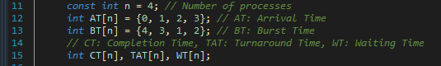

  - n: Defines the number of processes (4 in this case).
  - AT (Arrival Time): The time at which each process enters the ready queue.
  - BT (Burst Time): The time required by the process to execute on the CPU.
  - Result Arrays: Arrays to store calculated results: Completion Time (CT), Turnaround Time (TAT), and Waiting Time (WT).

- 2. Core FCFS Logic (Calculation Loop)
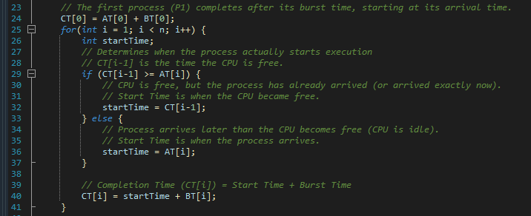
- 3. Metric Calculation
These formulas are standard for evaluating any scheduling algorithm:
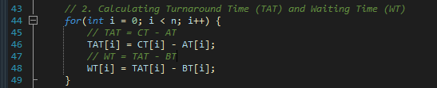

- Turnaround Time (TAT): The total time a process spends in the system (from arrival to completion).
- Waiting Time (WT): The total time a process spends waiting in the ready queue.

Output
